 TMB SINGLE DISC FLOOR MACHINE (available in 17” and 20”)

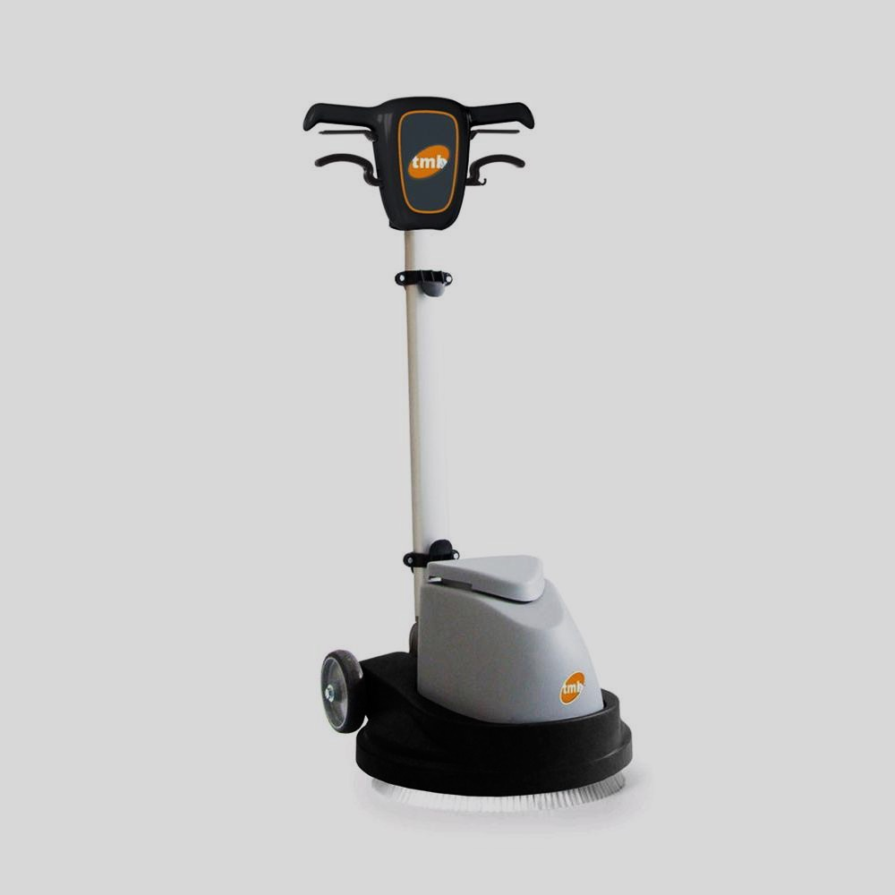

Equipped with a stainless-steel frame and PPL base covering, they combine efficiency and versatility with modern ergonomics. Depending on the type of work to be performed, you can choose between models with belt or gear transmission.

**Model TX43G and TX50G** – 160 RPM Professional cable monobrush, with nylon gear transmission, suitable for ordinary maintenance of floors. The machine can be equipped with an extra weight of 15 lbs, optional. Furthermore, the detachable power cord facilitates transport and maintenance operations.

**Model TX43 and TX50** – 180 RPM Professional cable single disc machine with belt transmission.

**Model TX43-400 and TX50-400** - Professional cable single disc machine, with belt transmission. Available in the 180 RPM version for basic cleaning or stripping, and at 400 RPM for polishing or dry maintenance.

**Model TX43-DS and TX50-DS** - The DS version is dual speed, at 180/400 RPM, with a push-button variator. The belt drive makes these single disc machines very quiet and allows their use even in environments where maximum discretion is required in cleaning operations.